Team 13: An Lam, Junwoo Jang, John Manacup, Mckinley Parker

CS: 3365 – FALL - 2021

Professor: Michael Shin

TA: Bipin Chhetri

Date:11/28/2021

Project: Supermarket Check Out/Inventory System

**Introduction:**

This software is to help the cashier to check out the items from the customer. The system manages the customer account and the inventory manually and automatically. Once you start the program, you are required to Log-in either as a customer (check-out system) or as a manager (Manage Inventory). In the check out system, you can choose products through a barcode (you can upload a barcode image file). After you choose the products through barcode, the product’s description will be on the left top. (Name, Description, Type, Price). You can also look up items through product ID. When you are trying to purchase a product that changes the price depending on the weight, especially a fruit or vegetable, you can use scale to weigh the product.

After you choose all products that you want to purchase, you are required to type customer’s information (Name, Phone number, Address). After Log-in, if you have membership, the discount will be applied. When you make payment, you can pay with Credit/Debit, or Cash, or Check. With the Credit/Debit card payment, you are required to type the card information. With the Cash payment, there will be change if you pay more than total price. With the Check payment, you can either scan the check (you can upload the check image file) or manually type the information of the check (Amount, Data, Time). If the balance of the check is more than the total price, there will be change. After you make the final payment, there will be an authorization code for your order and the total points depending on total purchase amount will be applied to your account. With the authorization code, the system will approve/reject the payment.

In Manage Inventory, you can see all items with the item’s id, name, price, availability, threshold, supplier, number of orders. You can also particularly see the list of orders with OrderID, supplier name, Data and status, and manage the orders.

**Acknowledgement**:

Software development model: Water-Fall model.

Version: 1.0

Testing Stages: Development testing

Non-functional requirements: None

**Technical Information:**

* **Programming Language:**
  + java version "17" 2021-09-14 LTS
  + Java(TM) SE Runtime Environment (build 17+35-LTS-2724)
  + Java HotSpot(TM) 64-Bit Server VM (build 17+35-LTS-2724, mixed mode, sharing)
  + **GUI:** JavaFX-SDK-16 Version 16
  + **JRE:** JavaSE-1.8 - jdk 14.0.1
  + **JDK:** JavaJDK 17

**Current features:**

* **InventoryManagement:**
  + **Show inventory/product list:** Show the product list
  + **Show the product under threshold:** Show the product under threshold
  + **Automatically Send inventory order:** Send the order to the different suppliers for order the under-threshold items
  + **Automatically Check and notify the inventory:** Check and notify the products under threshold and store it in the system.
* **Checkout:**
  + **Show Item List:** Show the item list
  + **Show Item Description:** Show the description of the item
  + **Scan Item by barcode:** Scan item by barcode
  + **Scan Item by Enter ID:** Enter the id to obtains the items information
  + **Weight Item:** Weight Items
  + **Make Payment by Cash:** Pay by cash
  + **Make Payment by Credit/Debit:** Pay by credit card/debit card
  + **Make payment by Check:** Pay by check
  + **Make total:** Charge customer
  + **Show customer details:** Cashier can see customer details
  + **Show the total, tax, discount, paid amount:** See the payment
  + **Show check information:** show information from check
  + **Scan check:** Read information from a check
  + **Debit/Credit Reader:** Read information from credit/debit card
  + **Show the total, tax, discount, paid amount:** See the payment
  + **Print receipt:** Print the receipt
  + **Till control:** open and close the till
* **Customer Display:**
  + **Login:** Obtains customer information
  + **Show Item List:** Show the scanned items
  + **Show customer information:** Customer can see customer details
  + **Show the total, tax, discount, paid amount:** See the payment

**Improvement requires:**

* More development tests
* Move to Release testing
* Implement non-function requirements

1. Requirements Modeling:

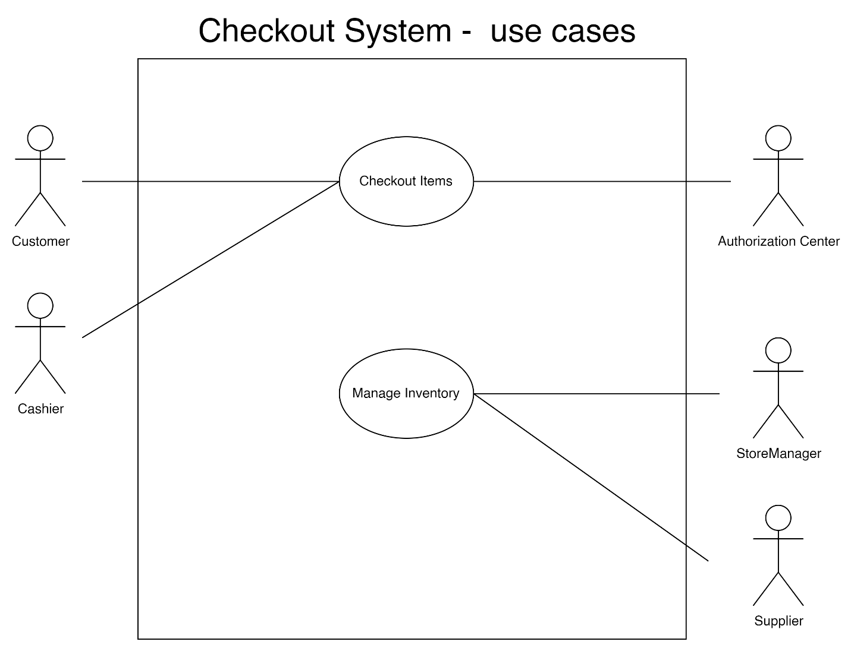

**Use case name:** Checkout Items

**Summary:** Cashier process each items, system verify the customer is loyal customer, cash register obtains product information and product inventory, product information is shown for both cashier and customer, bulk items are weighted in scale, display total price with tax, customer makes payment, cashier takes payment, display and print receipt.

**Actors:** Customer, Cashier, Authorization Center

**Precondition:** Customer has items to check out.

**Main Sequence:**

1. Cashier starts to process the items of the customer by retrieving the identification number of the items by scanning the barcode.

2. A customer is prompted to enter a phone number and member PIN to verify if the customer is loyal.

3. System confirms that the customer is a loyal member.

4. Cash register obtains product information from the product inventory.

5. Cashier continues to process the remaining items.

6. System outputs item description and price in the customer order receipt printer of each item checked.

7. System displays item description to both the cash register and customer display.

8. Cashier presses the TOTAL button once and the till is automatically opened after all items are processed.

9. System calculates payment amount including tax and displays total price and tax to both cash register and customer display. The printer prints total price and tax.

10. Cashier enters the payment type.

11. Customer enters a card into the credit/debit card reader.

12. System sends a message to the credit/debit card authorization center to verify the card.

13. Authorization center accepts the card and returns an authorization code.

14. The system calculates the credit point based on the total price and adds it to the customer account.

15. Cash register computes the amount of change and displays it.

16. System prints out the receipt.

17. Cashier closes the till.

**Alternative Sequence:**

1 If manual from keypad, cashier enters the number followed by the function key ITEM-ID.

3 If the customer is not a loyal member, go to step 4.

6.1 If items are in bulk, Cashier places items on the scale to calculate the final weight and presses the SCALE button.

6.2 The system calculates the price.

10.1 If the cashier chooses the cash payment type, the cashier enters the amount of payment.

10.2 If the cashier chooses the check payment type, the cashier would use the check reader to read the check and the system will verify the check. Once accepted, the system will update the receipt printer to add details of the check.

10.3 If no payment type is made, cancel the orders. go step 17.

13. If the card is not accepted, go step 10.

**Postcondition:** Customer successfully checked out items.

**Use case name:** Manage Inventory

**Summary:** System uses a timer to be set at night. After a minute passes, the system will check the inventory, if the item falls below a certain threshold, the system will store and display the message to the storage manager.

**Actors:** Store Manager, Supplier

**Precondition:** Items are available in the inventory.

**Main Sequence:**

*1. Store Manager sets up a timer (night time)*

*2. After a minute passes, System will check the inventory of items.*

*3. System creates and stores an inventory message.*

*4. At night time, the timer is triggered to automatically send the inventory supplies request to the suppliers and the order is store in the inventory orders*

**Alternative Sequence:**

3. If quantities of items are still above threshold, repeat step 2.

**Postcondition:** The inventory orders are sent and item inventory is replenished to full.

1. Requirements Analysis:
   1. static model: classes and their relationships

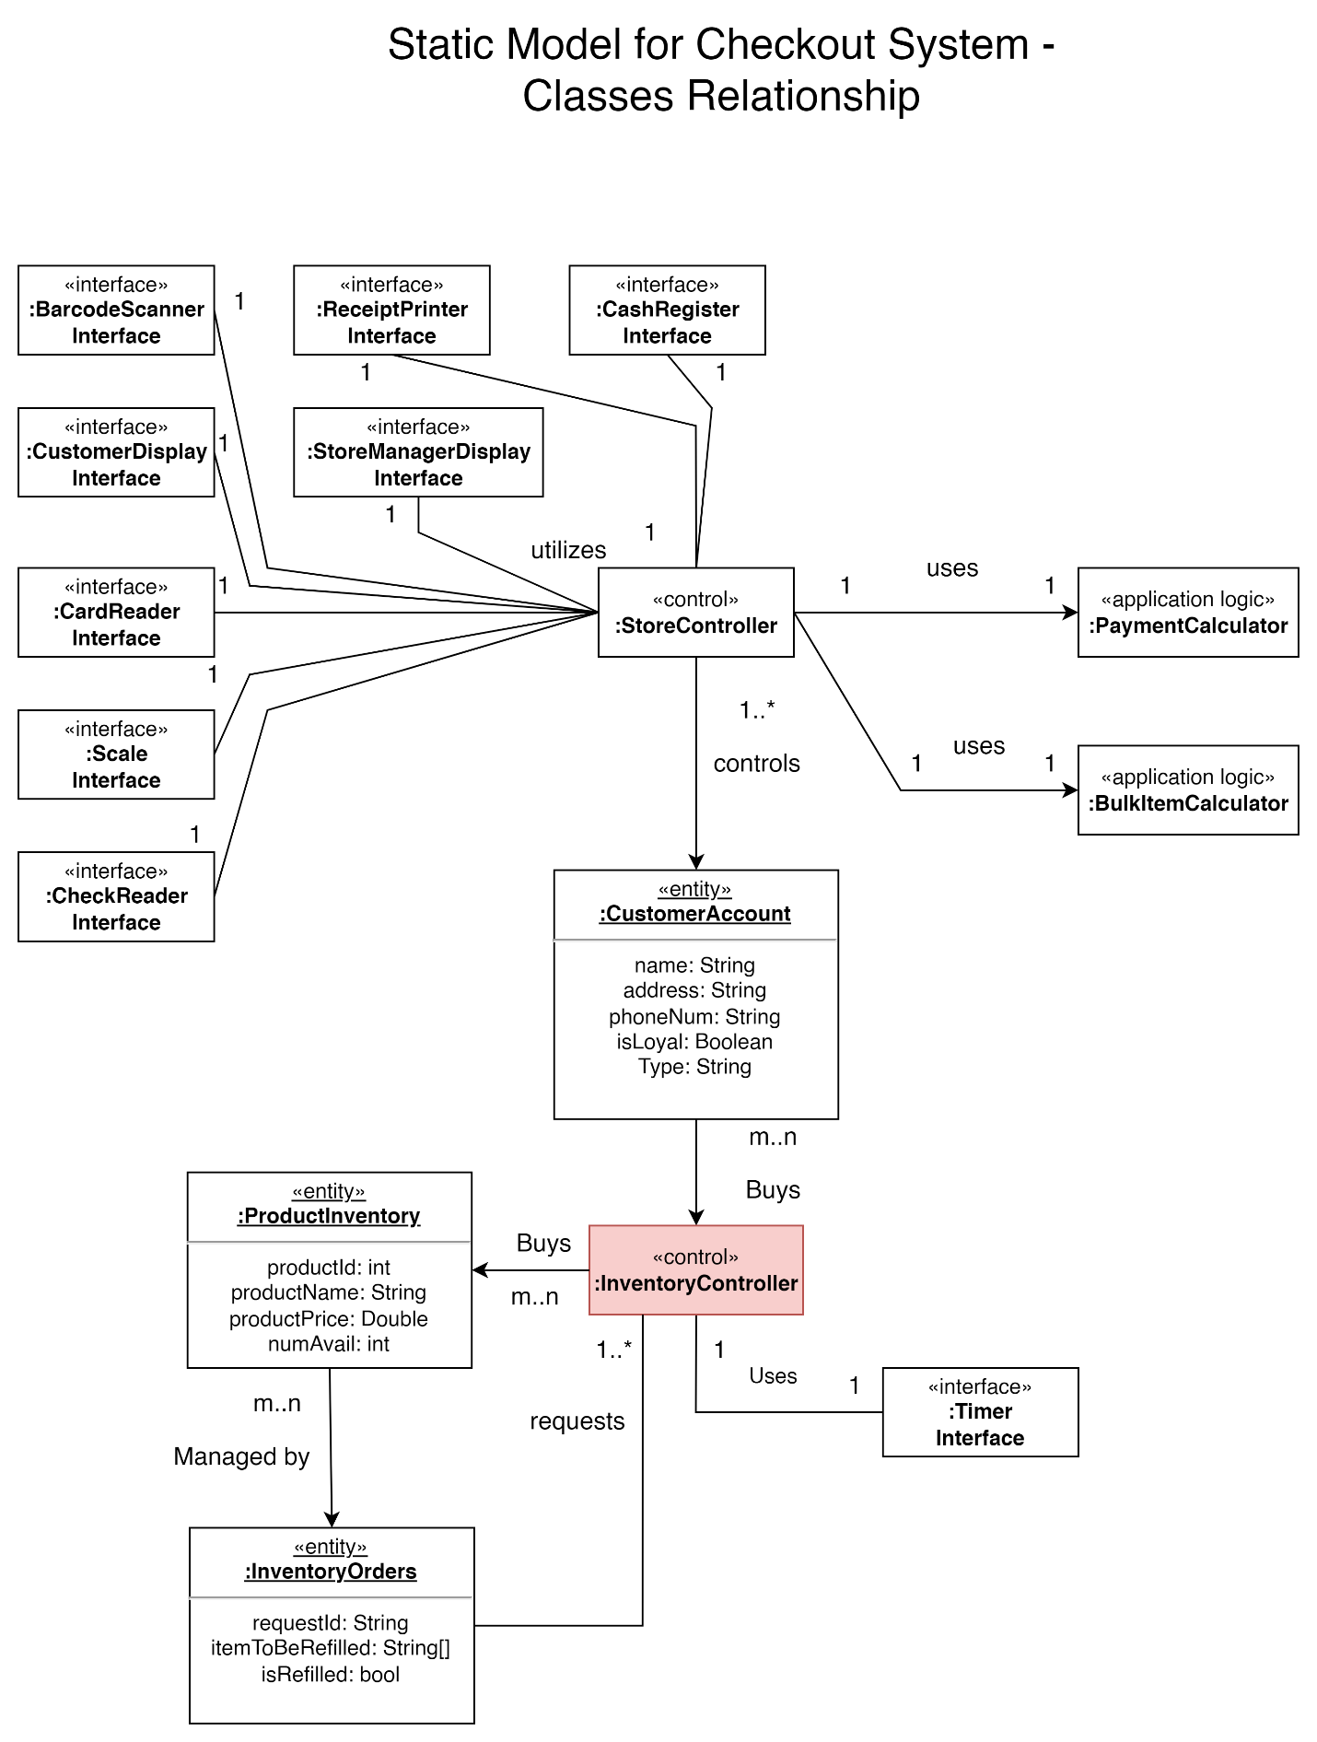

* 1. the interaction model:

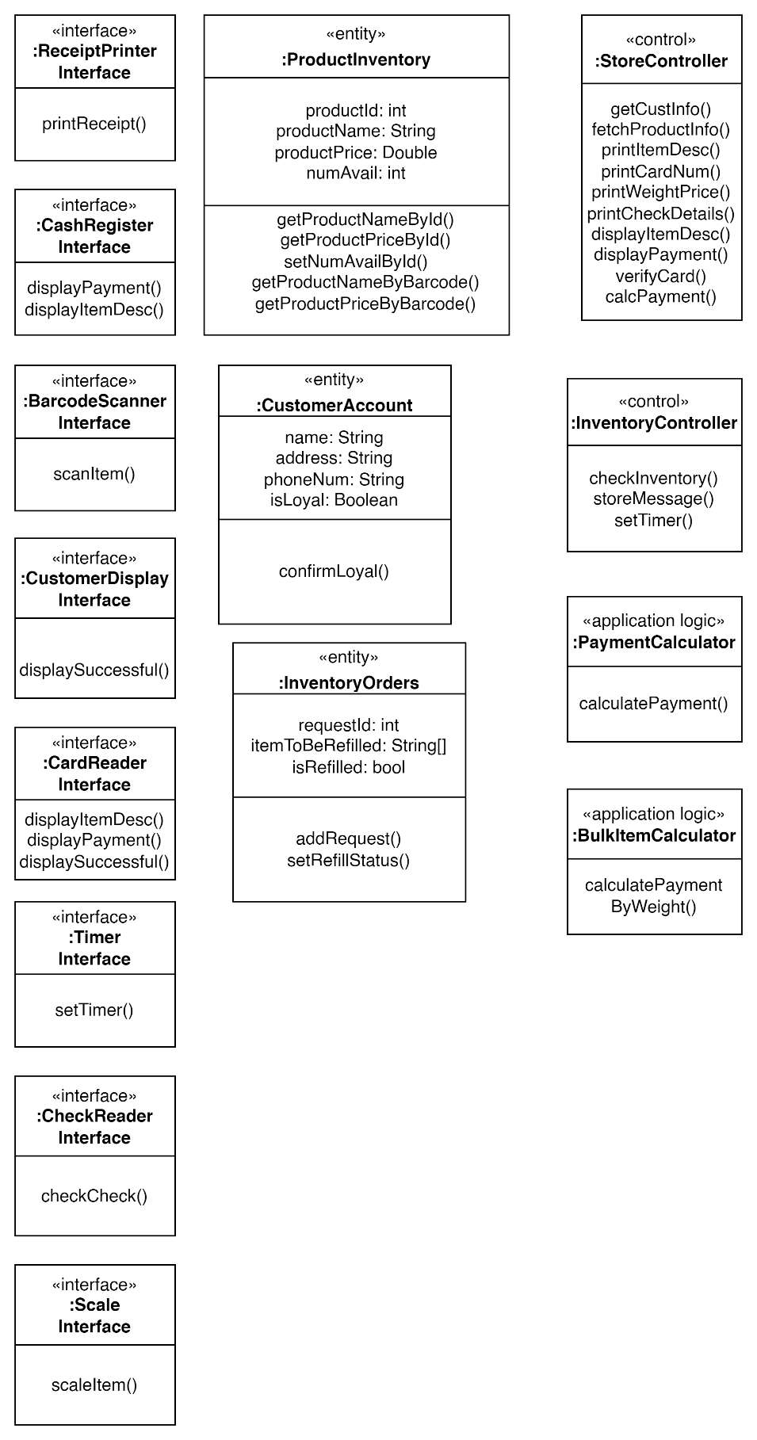

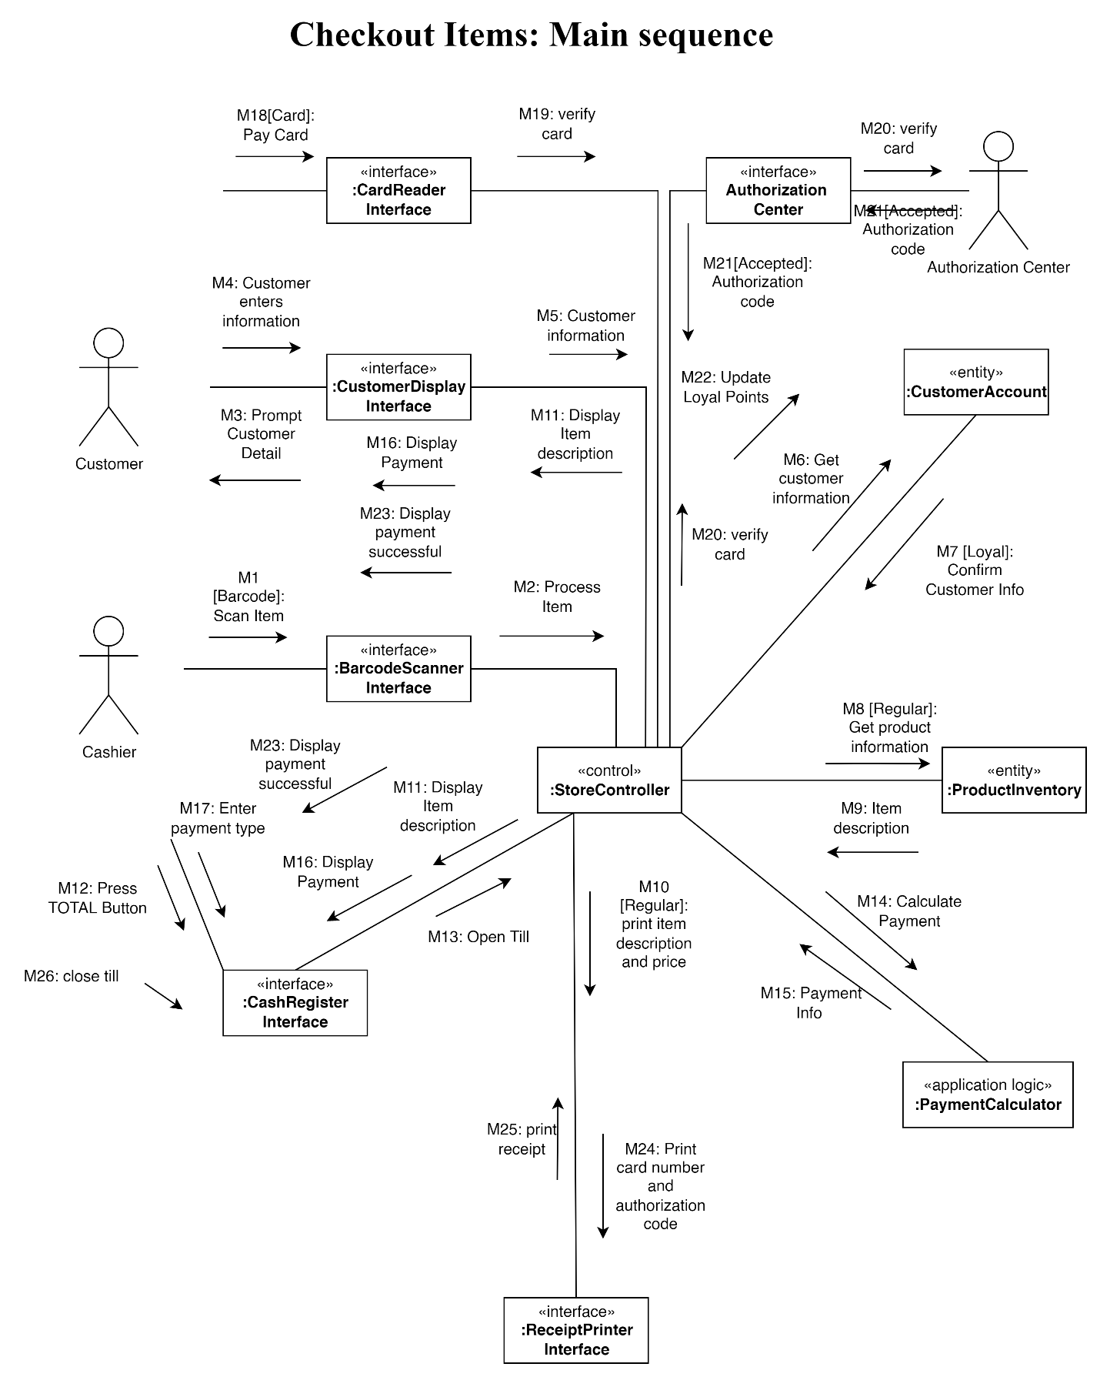

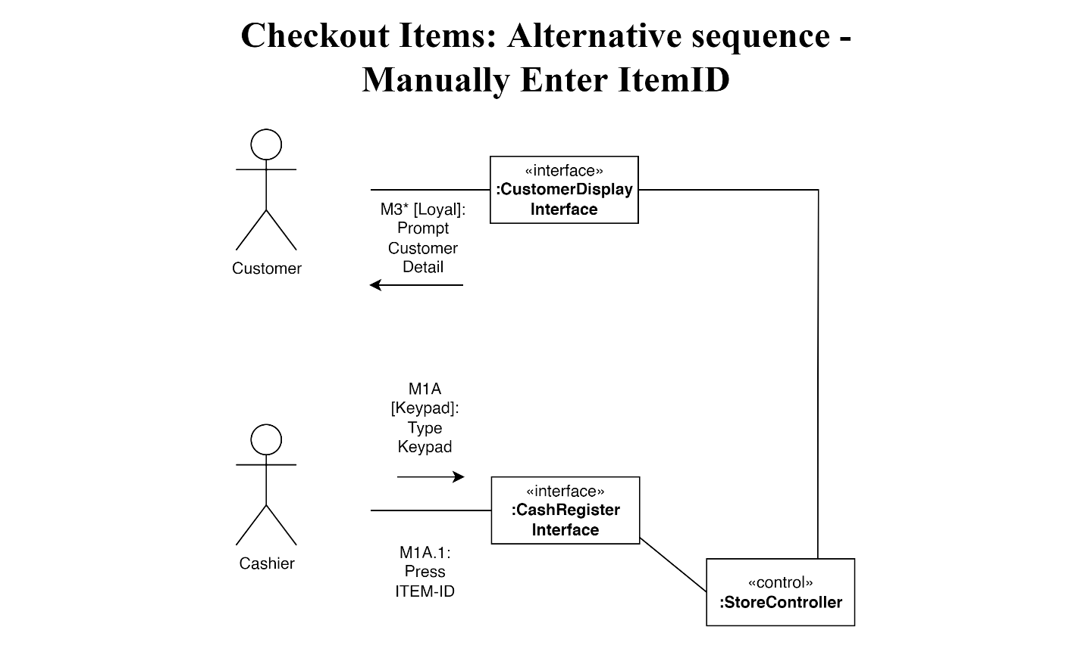

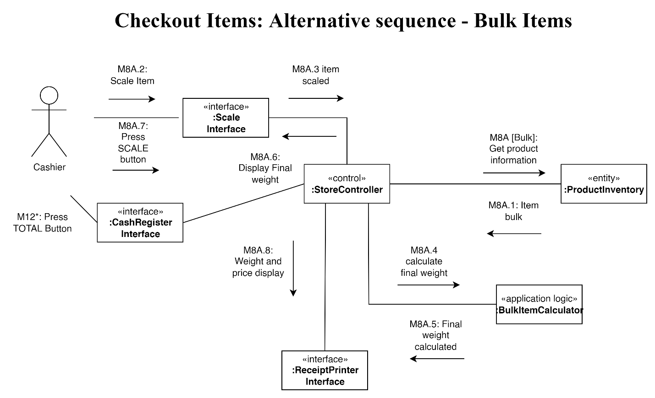

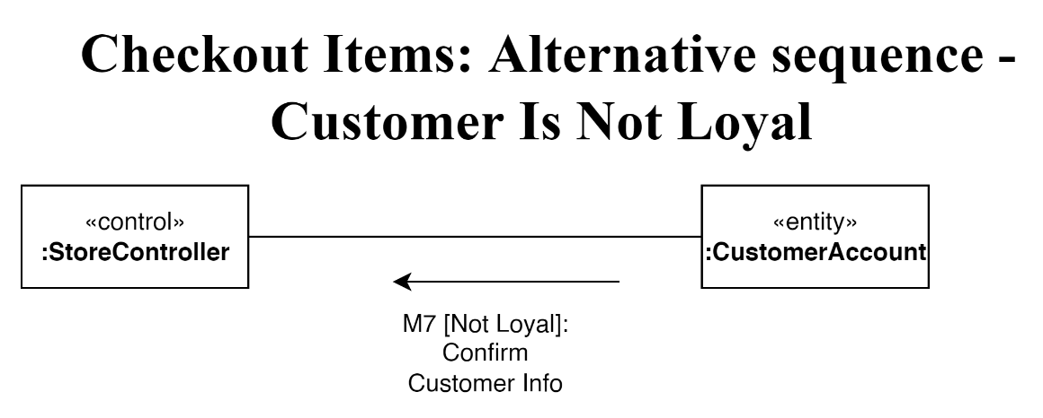

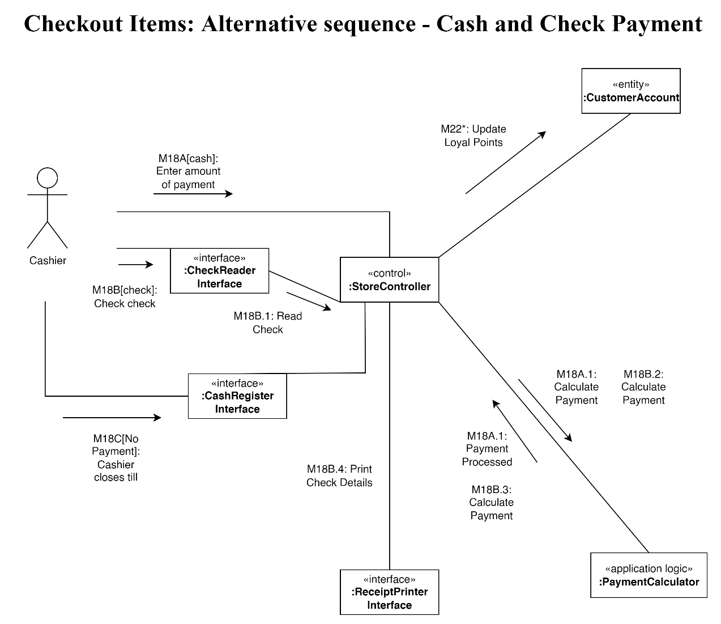

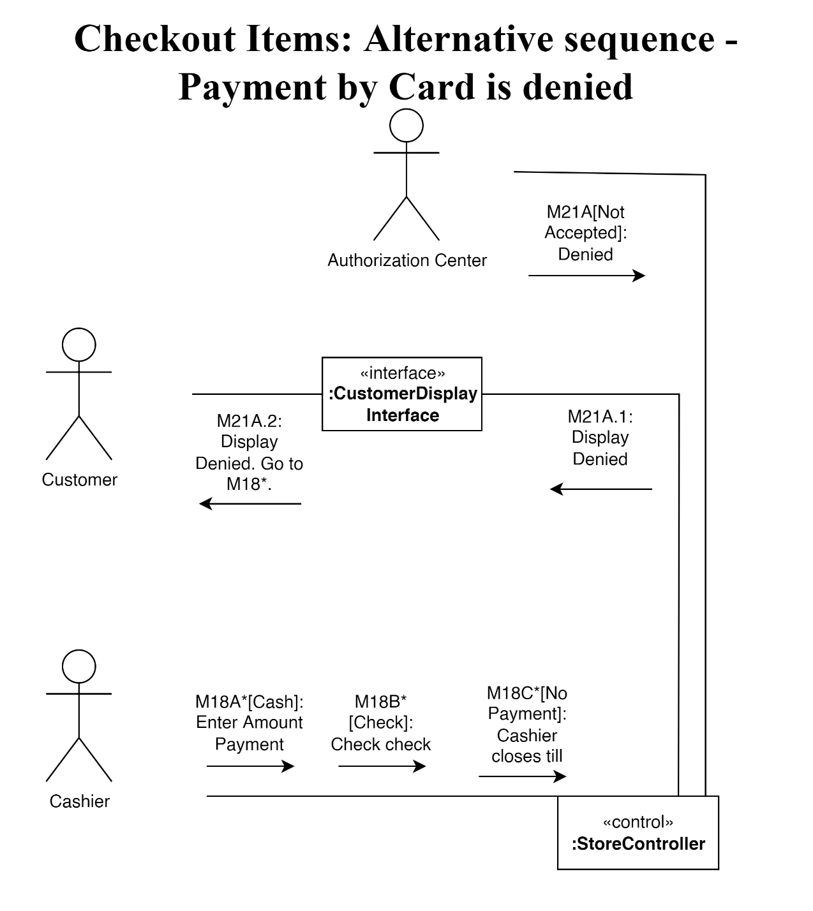

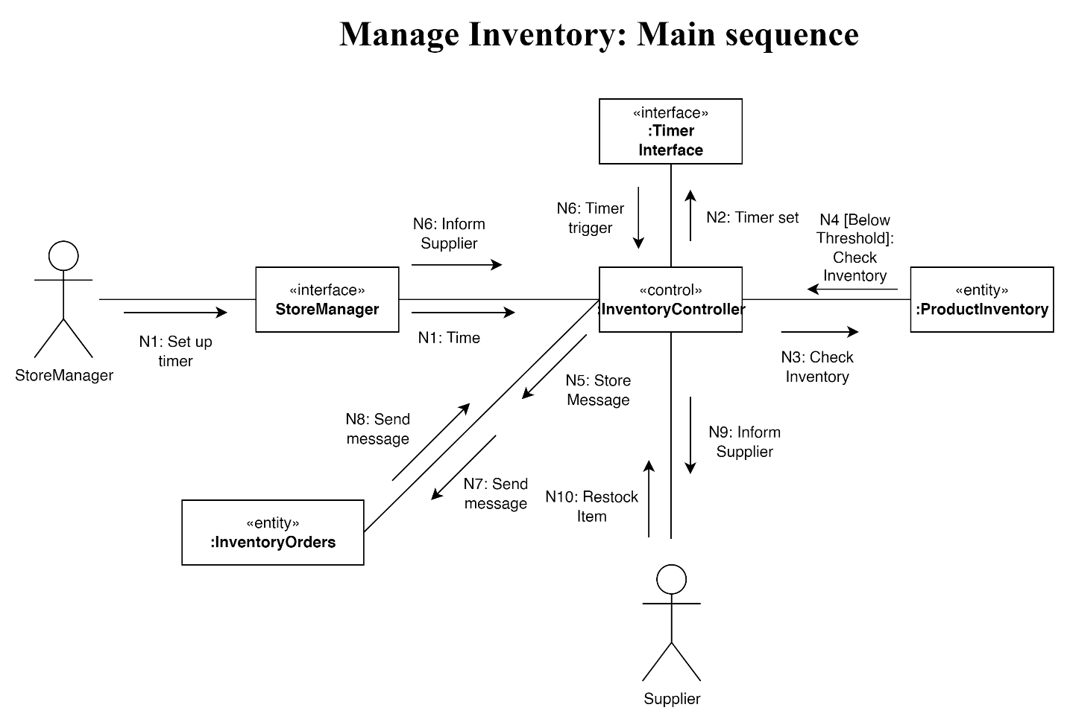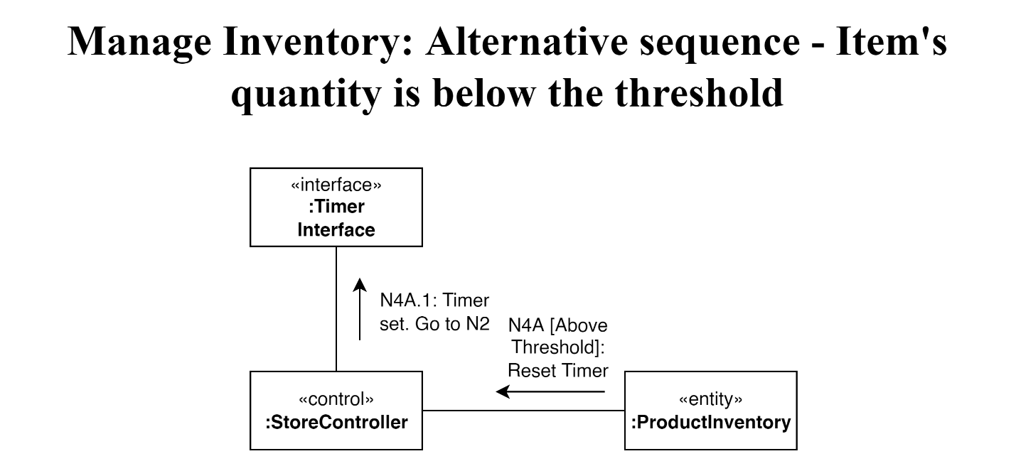

* 1. the operations of classes identified

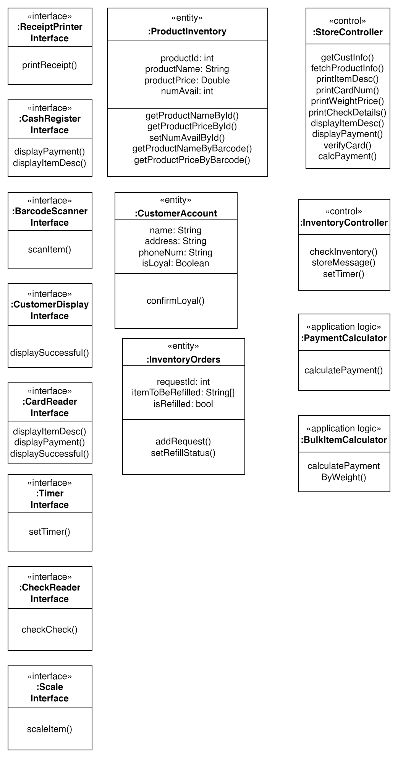

1. Design:
   1. the software architecture:

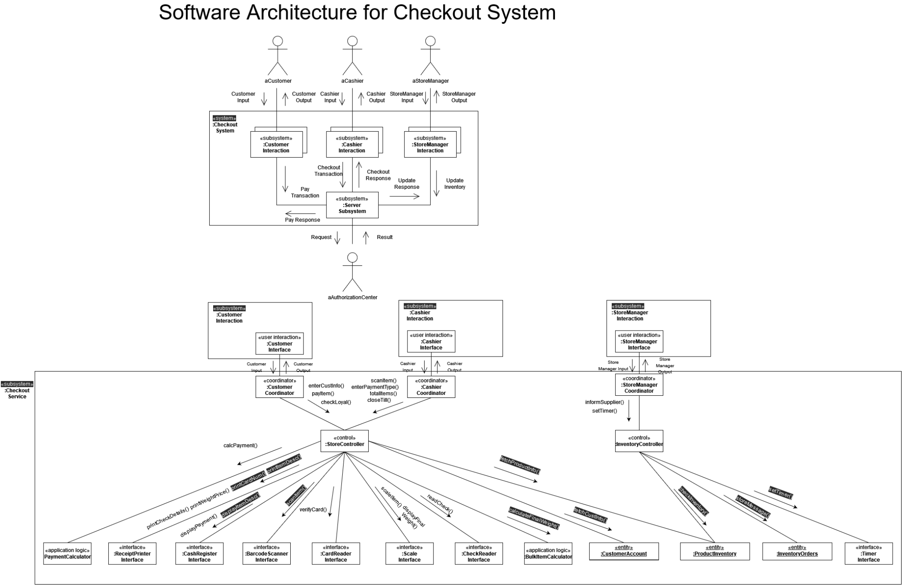

* 1. database:

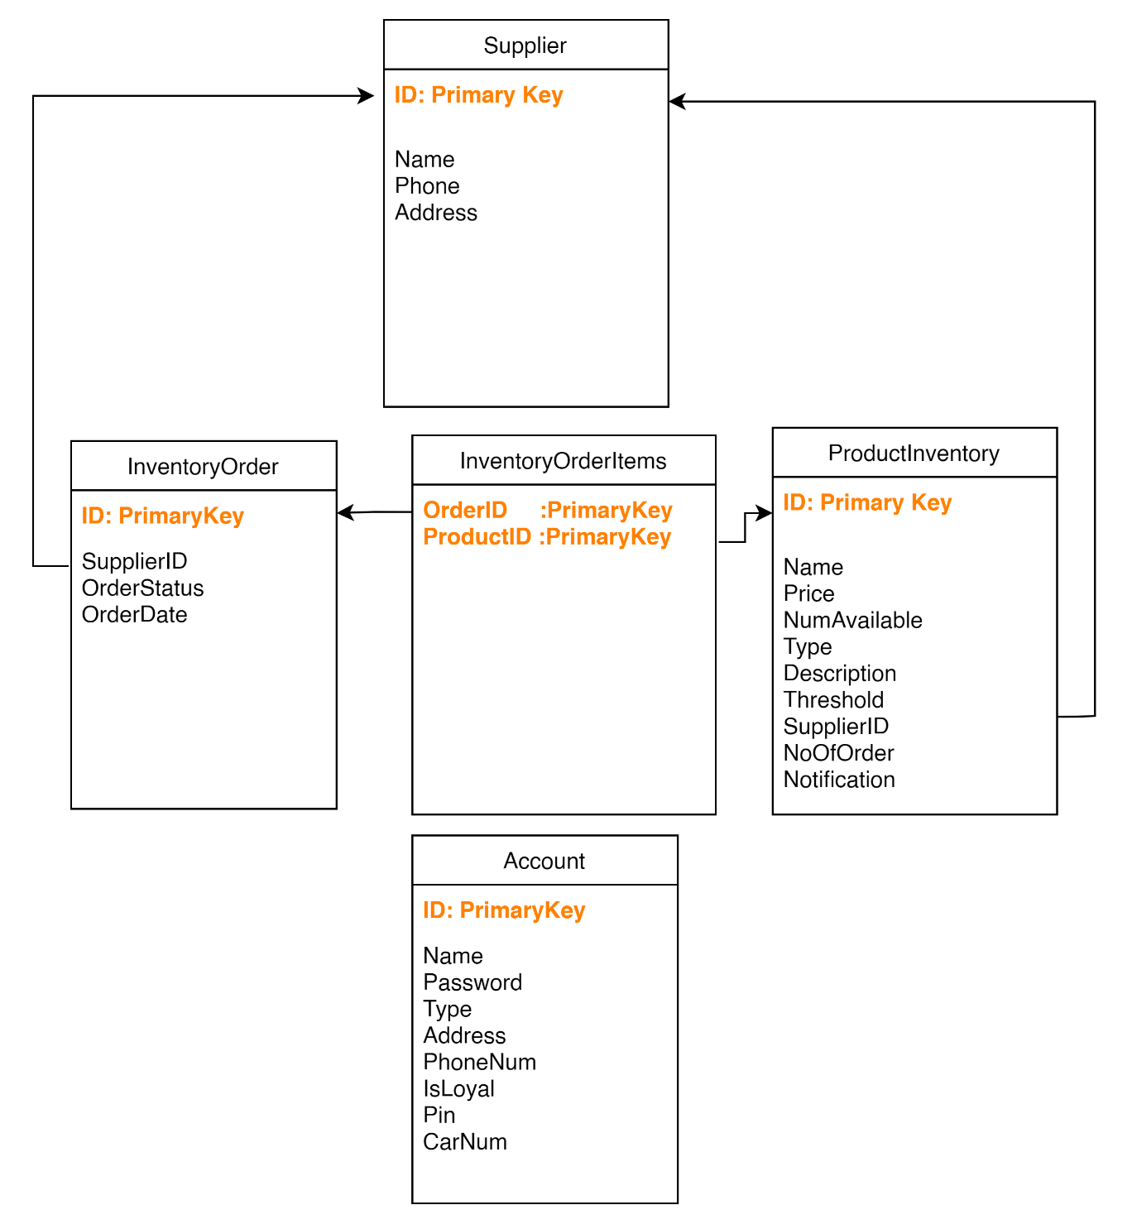

1. Implementation

* [SofwareEngineering.zip](https://github.com/lockerroomtalks/cs3365project/blob/main/SofwareEngineering.zip):
  + Source code
  + Compiled code
  + Database.dp
* Acknowledgement:
  + - Files:
      * Time.txt: To get and store time to make an inventory order at a setting time(night time)
    - Authorization center System
      * The Checkout system is just to send the message to the authorization center. And receive fake feedback from authorization center
    - Supplier System
      * The inventory system sends the message to the different suppliers and receives fake information from the suppliers.
    - Simulation:
      * Barcode reader
      * Check reader
      * Credit/Debit card reader
      * Printer
      * Receipt
      * Scale

1. Presentation:

<https://www.youtube.com/watch?v=xdR6KjOugZQ>